
BANKING FINANCIAL

INTRODUCTION:
This project focuses on analyzing banking financial data to understand customer behaviour, transaction patterns, loan activities and overall financial performance .The raw dataset was first cleaned and transformed using python to ensure accuracy and consistency. After pre-processing, the refined data was stored and analysed using MySQL to extract meaningful insights through structured queries. Finally, an interactive POWER BI dashboard was created to visually present the key trends, metrics, and patterns, enabling better decision-making for banking operations.
OBJECTIVES:
- Data Cleaning in Python
- Removing missing, duplicates and inconsistent records.
- Standardize formats for date, currency, and categorical values.
- Engineer useful features for deeper financial analysis.
- Ensure the dataset is accurate, reliable, and analysis ready.
- Data analyses using Mysql
- Store the cleaned dataset in a structured database.
- Perform Mysql queries for customer segmentation, loan performance, and transaction analysis.
- Extract summary statistics and trends to support decision making.
- Identify patterns such as high-value customers, transaction frequencies, and risk indicators.
- Power BI dashboard Creation
- Visualize key banking metrics using interactive charts.
- Build dashboards that highlight customer trends, deposits, loans, revenue, and risk.
- Help stakeholders quickly understand performance and take action.
- Create drill-down reports for deeper insights into customer and financial activities.

 PYTHON CLEANING

- DATA CLEANING IN PYTHON:
- Imported all the libraries for cleaning and visualization.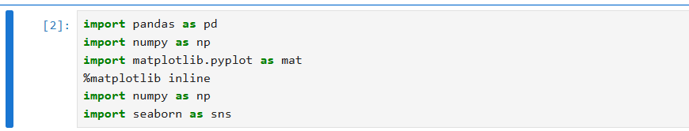
Uploaded a CSV file.
- In data analysis and data pre-processing workflows, reading input data correctly is the first and most important step. CSV commonly used for storing tabular data.

This documentation explains how to read a csv file using python in the pandas library.
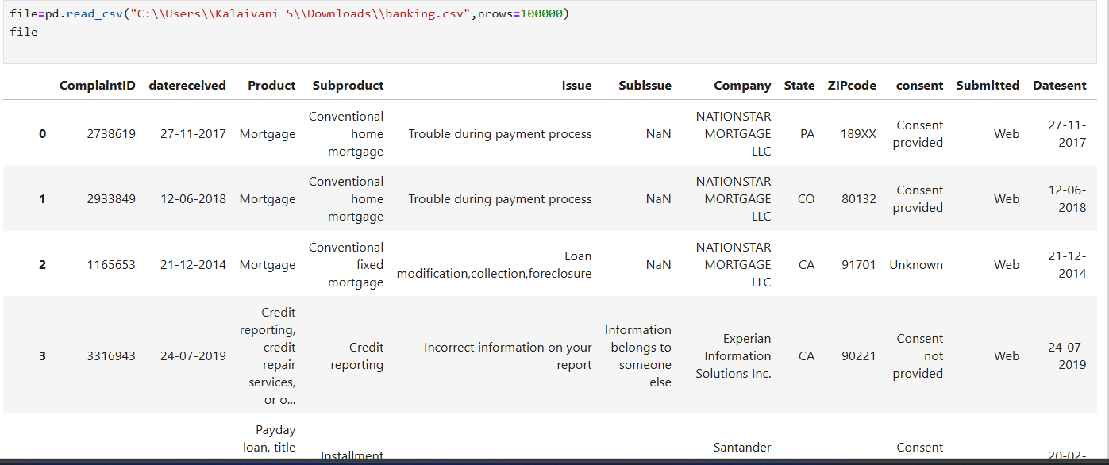
- Getting the information about the dataset:
- Using the info() method in python during data cleaning.
- Total number of rows and columns –To Understand dataset size.
- Column names –To see all fields available.
- Number of null values-used to detect missing data.
- Data types of each columns.

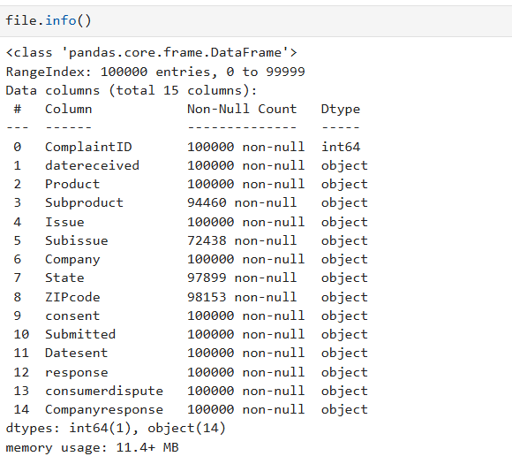
- Getting the summary of the dataset :
- It provides statistical measures for numerical columns like(count, std, min, max).
- Count-num of non missing values.
- Mean- average value.
- Std- standard Deviation.
- Min- minimum values.
To quickly understand the data quality.
To identify outliers.

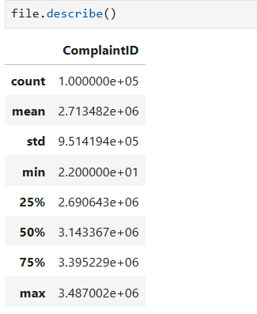
- To identify and count missing values:
- Checks every values in dataframe.
- Returns the count if the value is missing(NaN)
- Sum() adds up all the True values in each column.
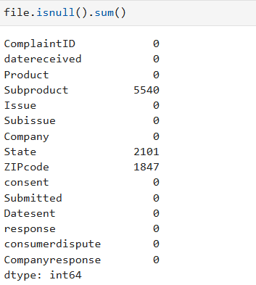

- Filling Null values in a column using related column information:
- Used the information from the issue column to fill the sub-issue.
- Missing values in Sub-issue create incomplete records.
- The nulls affect analysis, grouping, and reporting.
- Since each issue has a correct and corresponding sub-issue, it is reliable to fill missing entries using the mapping.

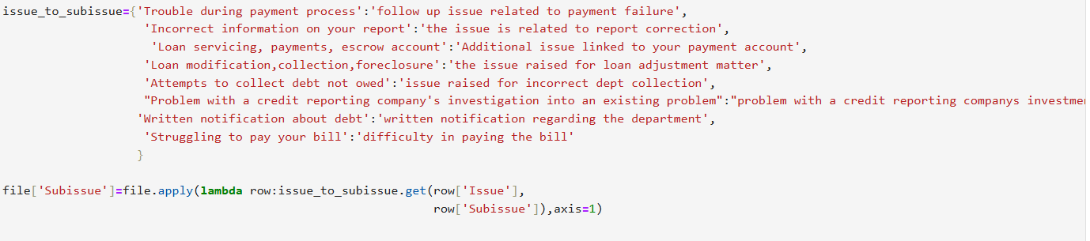

- Missing Sub-issue entries lead to incomplete records:
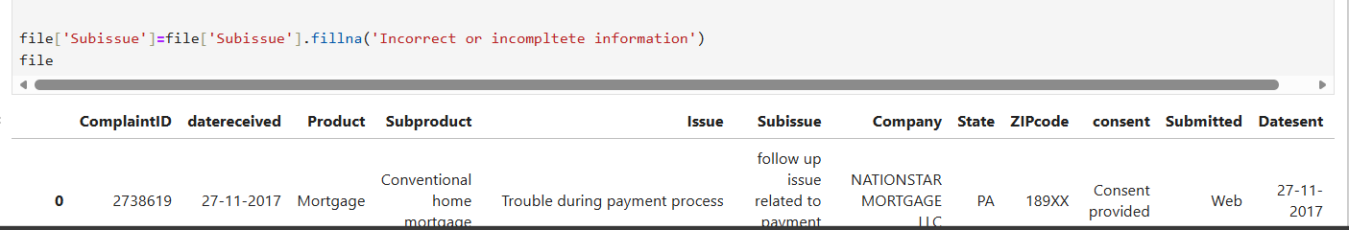
- Filling Null values in Sub-product using forward fill:
- Forward fill take the last known valid value from the column and fills it downward into the next null row.
- All missing Sub-product values are filled.
- Filling Null values in State using Backward fill:
- Backward fill take the previous known valid value from the column and fills it upward into the next null row.
- All missing State values are filled
Replaces the values in ZIP-code:
- The Zip-code was missing
- The Zip-code was incorrectly formatted.
- This replacement ensures that the dataset maintains valid geographical information, improves data accuracy, and supports better analysis in later stages.
Replaces the –values into NaN:
- The Zip-code have the negative values so, I replaced the values as nan

VISUALIZATION IN PYTHON:
- Using Sea-born and Matplotlib
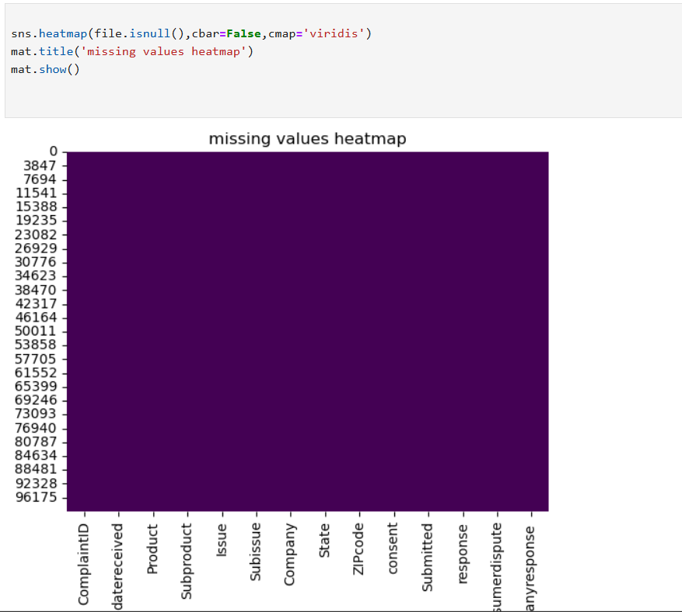
- Heat-map for missing values

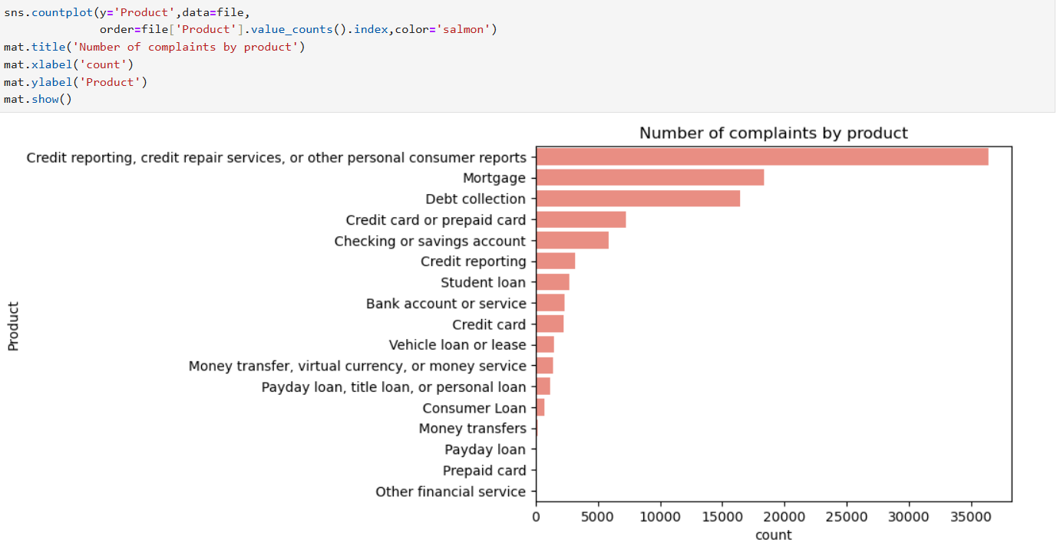
- Bar-chat chart for complaints by product

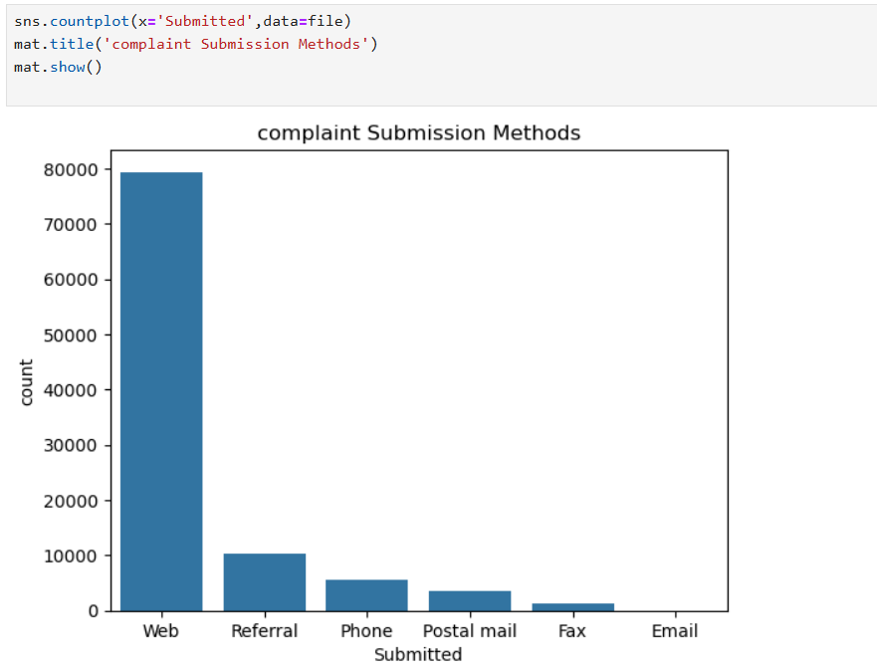

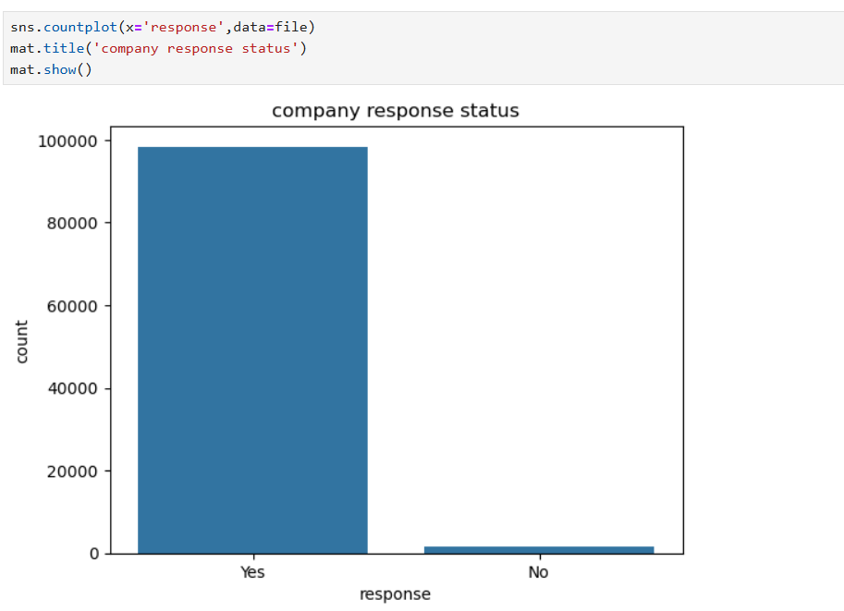
- Company response status counts .

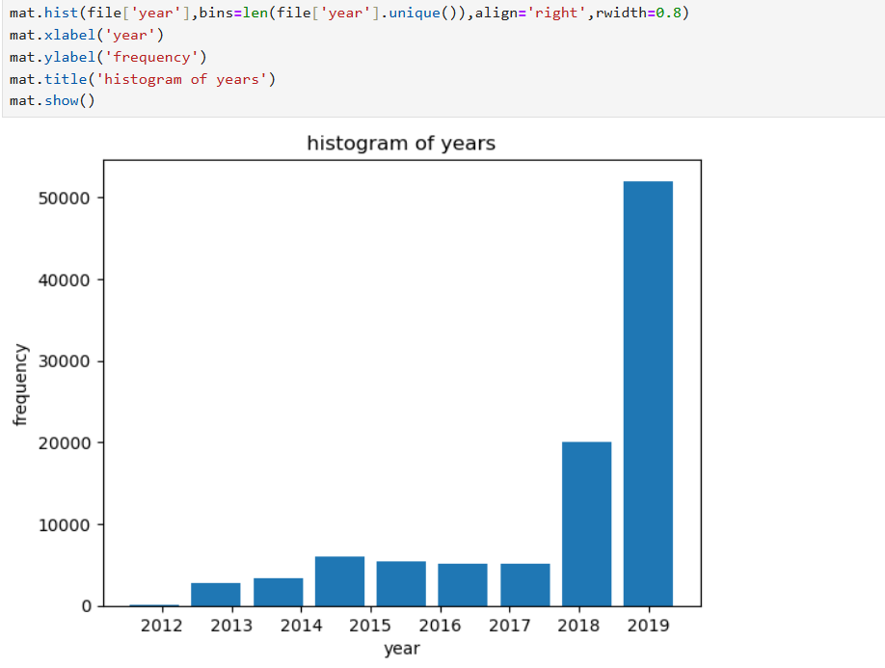
- Year wise complaint counts.

MYSQL QUERIES
TABE DESIGN:
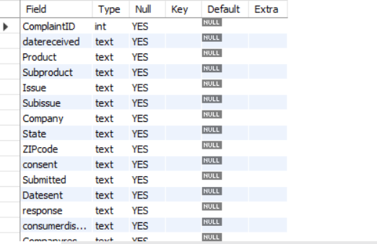

SQL QUERIES:
SELECT- It fetches the data in the table using the select query.
- Select*from banking;
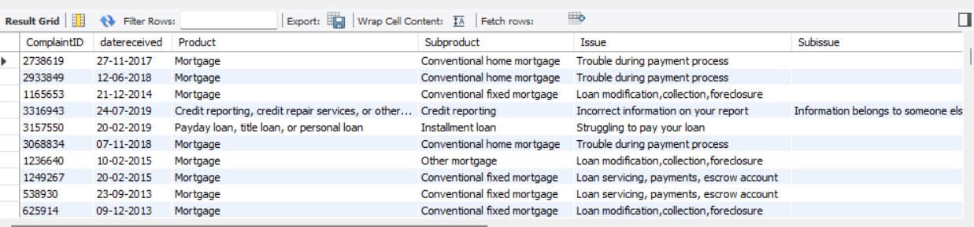
- It fetches all the columns from banking table.
WHERE- return the row where the data is.
- Select * from banking where product =’mortgage’;
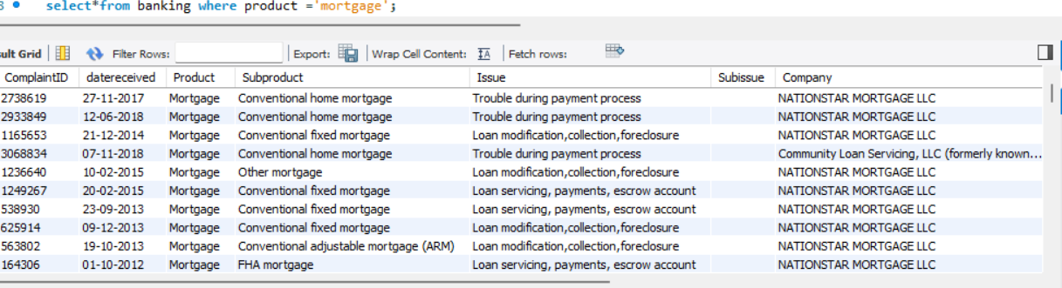
- Returns the rows where product is mortgage
DISTINCT-To get the unique value.
Select distinct product from banking;
- It retrieves the unique product
COUNT- The count is get the count of each row
- Select count (product) from banking;
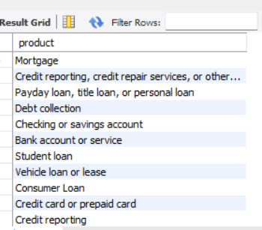
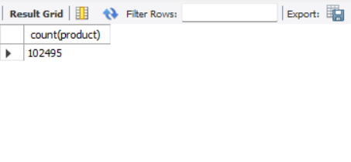
- It returns the count of the dataset.
COUNT &DISTINCT- I used for unique values count.
- Select count (distinct subproduct) as products from banking;
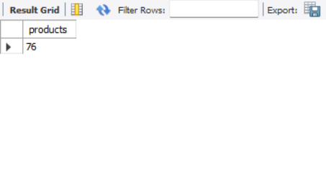
- It retrieves unique sub-products count.
ORDER BY- To get the values in the respective order.
- Select * from banking order by datereceived;
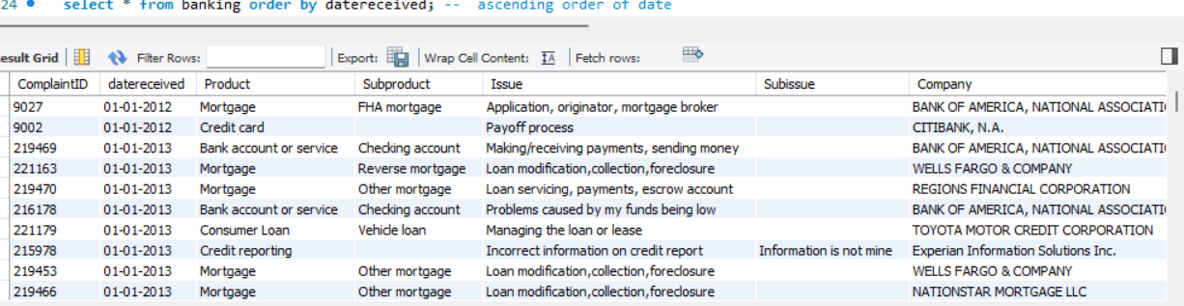
- It retrieves the datereceived columns in ascending order.
- Select * from banking order by datereceived desc;
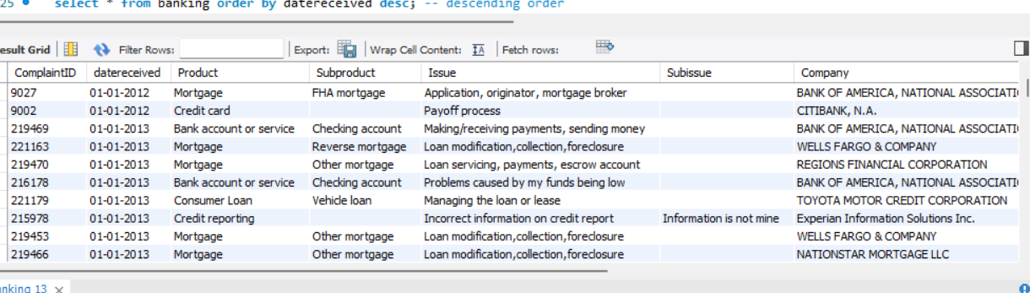
- It retrieves the datereceived columns in descending order.
- Select*from where subproduct='checking account' order by complaintID;
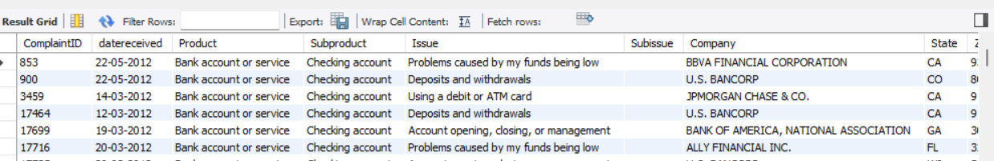
- It retrieves the sub-product is checking account based on the order of complain-ID.
GROUP BY- The group by is counts the sub-products in each products
- Select product ,count(sub-product) as pro from banking group by product;
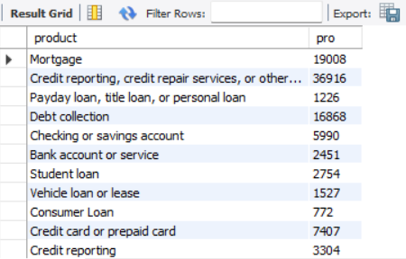
- It retrieves the counts Sub-products in each product.
MULTIPLE COLUMNS IN GROUP BY:
- Select submitted, response, count(*) as counts from banking group by submitted, response;
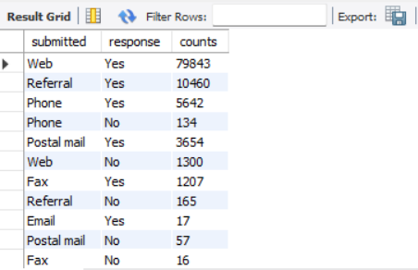
- It retrieves the count of the responses based on submitted.
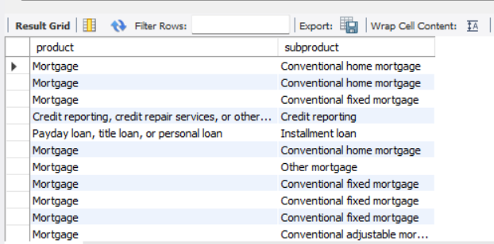
- It retrieves the values in Sub-product values.
LOGICAL OPERATORS:
AND-it filters rows where both conditions are true.
- Select company, submitted from banking where company='NATIONSTAR MORTGAGE LLC' and submitted='Web' ;
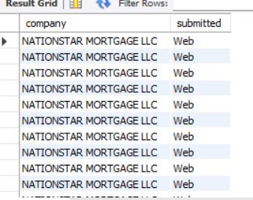
- It retrieves the company name and the complaint is submitted on web.
OR- it returns rows where the one condition is true.
- Select consumerdispute, companyresponse from banking where consumerdispute="yes" or companyresponse='closed with explanation';
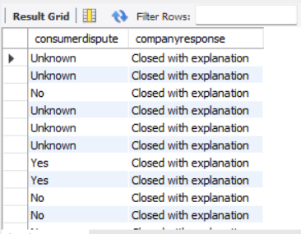
- It retrieves the consumerdispute=yes or companyresponse=closed with explanation.
View
A view is like a virtual table.
create view responses as select issue,subissue,company,companyresponse from banking where issue='Loan modification,collection,foreclosure';

- select * from responses;
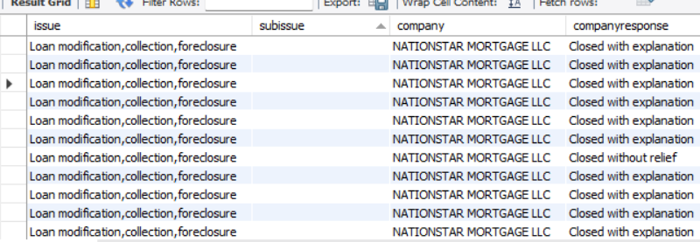

- Created responses table in banking which holds the issue,subissue , company and companyresponse.
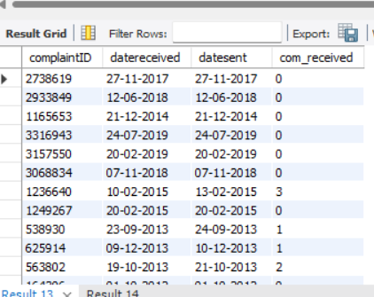
- Duration of the received and sentdate using the datedifference.
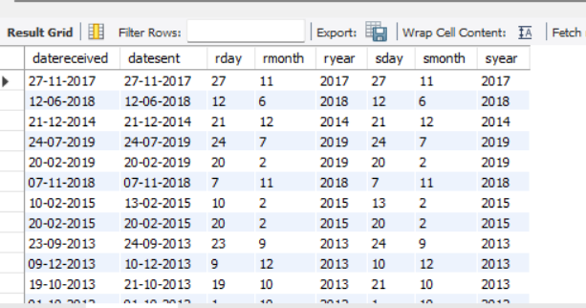

FUCTION:
delimiter $$
create function company_details(id int)
returns varchar(50)
deterministic
begin
declare details varchar(50);
select concat(company,state,ZIPcode) into details
from banking
where complaintID=id;
return details;
end $$
delimiter ;

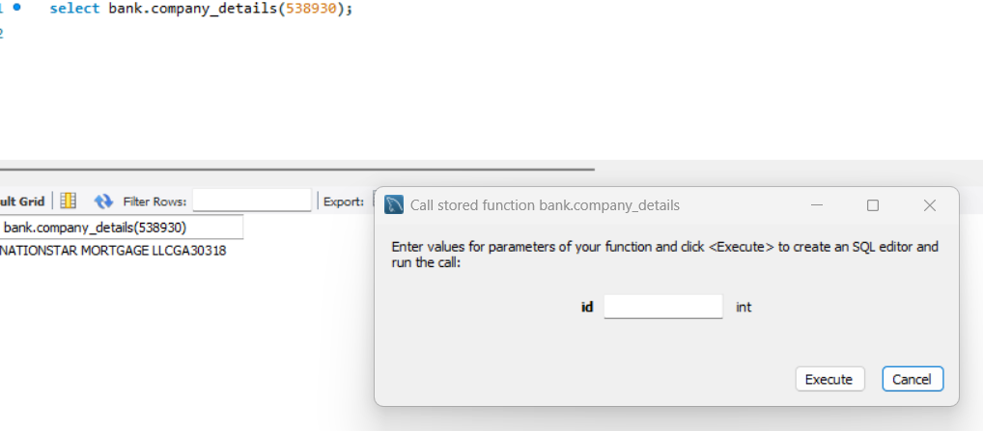

POWER BI DASHBOARD

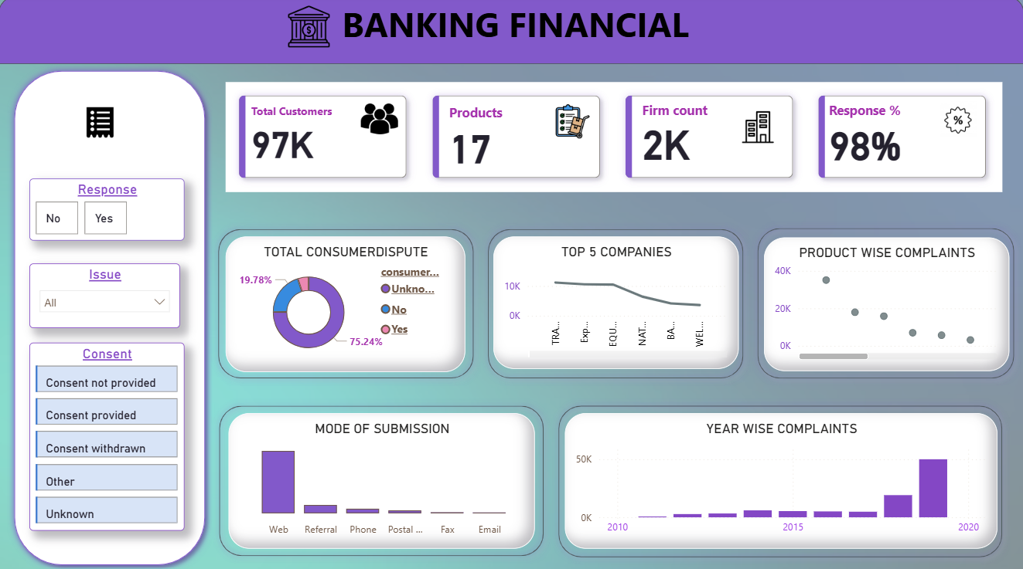

1. Overview
The Banking Financial Dashboard provides a comprehensive visual summary of customer data, product details, firm information, consumer disputes, and complaint trends. It is designed to help analysts and stakeholders monitor performance, identify patterns, and make data-driven decisions in the banking domain.
The dashboard uses KPIs, charts, and filters to offer an intuitive and interactive user experience.

2. Key Performance Indicators (KPIs)

Total Customers – 97K
- Shows the total number of customers associated with the financial institution. This helps measure customer base size and business reach.

Products – 17
- Indicates the number of financial products offered. It highlights product diversity and service range.

Firm Count – 2K
- Represents the number of firms or branches involved. Useful for understanding operational scale.

Response % – 98%
- Shows the percentage of customer responses or complaint resolutions.
A high value indicates strong customer engagement and resolution efficiency.

3. Filter Panel (Left Side)

Response Filter
- Options: Yes / No
Allows the user to segment complaints based on whether a company responded.

Issue Filter
- Dropdown filter to select specific issues for deeper analysis.

Consent Filter
- Includes categories like:
- Consent provided
- Consent not provided
- Consent withdrawn
- Other
- Unknown
These filters help analyze disputes based on customer consent status.

4. Visual Insights and Charts

A. Total Consumer Dispute (Donut Chart)
- Shows the distribution of dispute outcomes:
- Yes
- No
- Unknown
- Consumer disputes
Helps identify the proportion of resolved vs unresolved complaints.

B. Top 5 Companies (Line Chart)
- showed complaint data for top companies:
- Line chart shows trend across companies.
- Dot plot shows the complaint volume comparatively.
- Useful to understand which companies receive higher disputes and patterns.
C. Product wise complaints(DOT chart)
- Dot plot shows the product wise complaints volume comparatively.

D. Mode of Submission (Bar Chart)
- Displays how customers submitted complaints:
- Web
- Referral
- Phone
- Postal
- Fax
- Email
- Highlights the most commonly used channels (e.g., Web).

E. Year-Wise Complaints (Bar Chart)
- Shows the complaint volume across different years (2010 to 2020).
Helps identify growth trends, spikes, or reductions in complaints over time.

5. Dashboard Design Features
- Modern gradient theme based on purple and teal shades.
- Minimalist icons for clarity.
- Rounded card layouts for readability.
- Interactive filters for quick segmentation.
- Well-spaced visualizations for better user experience.

6. Purpose of the Dashboard
- This dashboard supports:
- Monitoring customer complaints.s
- Identifying top problematic companies.
- Understanding communication channels.
- Reviewing yearly performance.
- Supporting compliance and service improvement strategies.
CONCLUSION:
The Banking Financial Analysis project successfully integrates data cleaning database management, and interactive visualization to provide a comprehensive understanding of customer complaints and financial operations. Through Python, the raw dataset was transformed into a clean, structured, and analysis-ready format. MySQL enabled efficient storage and retrieval of insights, allowing deeper exploration of trends, product behaviours, customer interactions, and operational patterns. The Power BI dashboard brought these insights to life with intuitive visuals and KPIs, helping stakeholders monitor performance, identify issues, and make informed decisions.
Overall, the project demonstrates strong capability in end-to-end data handling – from pre-processing and SQL analytics to professional dashboard creation. This solution can support banking teams in improving customer service, resolving disputes efficiently, and identifying opportunities for operational enhancement. It reflects a practical, industry-relevant data analytics workflow suitable for real-world banking environments.

